Database Implementation Plan Report
Jace D. Swihart
IT-204 Intro to Data and Information Mgmt

Database Implementation
a. What data from the scenario is needed for the database and why?
This scenario requires student data, instructor data, and course data which are essential for optimal performance of the database. Student data provides details about students enrolled to Birchwood Lanes. The data includes names, address, email, date of birth, courses taken, enrolled courses, and enrollment date. Instructor data is required to provide details about instructors that work in Birchwood Lanes. The data includes names, address’, phone numbers, courses taught, etc. Additionally, course data is required to provide detailed information about the courses offered in Birchwood Lanes. The data required is interdependent which implies that all data about instructors, students, and courses have to be provided to ensure referential integrity is maintained.
b. To what extent is additional information needed to develop complete data requirements?
It is essential to consider the relationship between various data sets. For example, the entity student has a one to many relationships with the entity course. This implies that for the database to function properly, all the data sets have to be provided.

Relational Database Model
a. Design a relational database model. 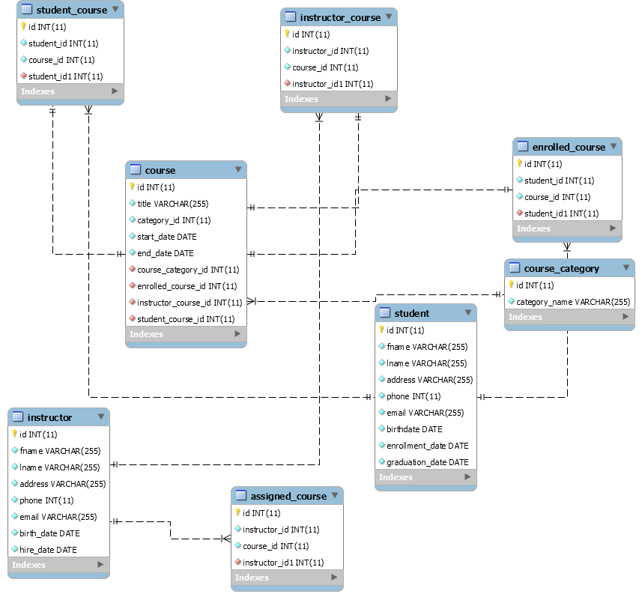

b. Develop a logical database model.
Database Selection
a. Why did you choose this DBMS?
The appropriate DBMS for Birchwood Lanes is MS SQL server. MS SQL server offers various robust features which are easy to use and effective in managing school database. The DBMS has a data size limit of 10GB (Nielsen, 2011). This is a relatively high data cap considering the kind of data stored by the school. This data size limit can support school operations without limiting the amount of data that can be stored. The annual purchase cost of MS SQL server is $1,790. The DBMS costs less compared to the purchase costs of Oracle, IBM DB2, and MYSQL. With MS SQL Server, the school will incur fewer costs but get quality service. The DBMS has high availability which implies that here will be less downtime and ensures that the school database is accessible at all times (Mistry, 2014). It includes JSON support, and the capability to stretch database hence can support scalability and maintain database performance. However, the DBMS can only operate in Windows. Thus, the school is required to have Windows platform to install and use the DBMS. Additionally, the DBMS requires an x64 Processor with speed 1.4 GHz and minimum 1GB memory to operate optimally (Petkovic, 2008). Overall, with MS SQL server, the school will have a robust DBMS that has high availability and costs less.
b. To what extent are there additional or alternative technologies that might assist Birchwood Lane Schools in managing its data?
Additional technologies that can be used with MS SQL server are data backup and replication technologies. Data backup technology creates a copy of the data stored in the database. This technology may be applied in Birchwood Lanes as a failsafe strategy in cases where the database becomes corrupted or altered. Additionally, replication technology may be essential as it keeps local copies of data in different nodes that will improve availability to various Birchwood Lane Schools.
Implementation Plan
a. Be sure to include all relevant information and steps.
First, the DBMS software will be installed in the school system. The database administrator will configure the database and set up security measures such as authentication control. Next, the school database will be created. Database tables will be created to store the data required. Once the tables are created, all the data collected will be entered via the MS SQL GUI interface. The database administrator will optimize the database queries to enhance the database performance. Additionally, the staff at the school will be trained on how to use the DBMS to manage data to help alleviate errors due to improper data entry.
b. Are there additional pieces of information necessary to develop a full plan for implementation or that may impact implementation success?
Fuzzy data or missing data may affect implementation of data. Since the school is using a relational database, missing data may affect the database results. The skills of the database administrator are a key factor in the implementation of the database. An ineffective database administrator may fail to configure the DBMS correctly causing the whole system to fail.

References
Mistry, R., & Misner, S. (2014). Introducing Microsoft SQL Server 2014. Microsoft Press.
Nielsen, P., & Parui, U. (2011). Microsoft SQL server 2008 bible (Vol. 607). John Wiley & Sons.
Petkovic, D. (2008). Microsoft Sql Server 2008 A Beginner's Guide. McGraw-Hill Osborne Media.

